Alan Woods

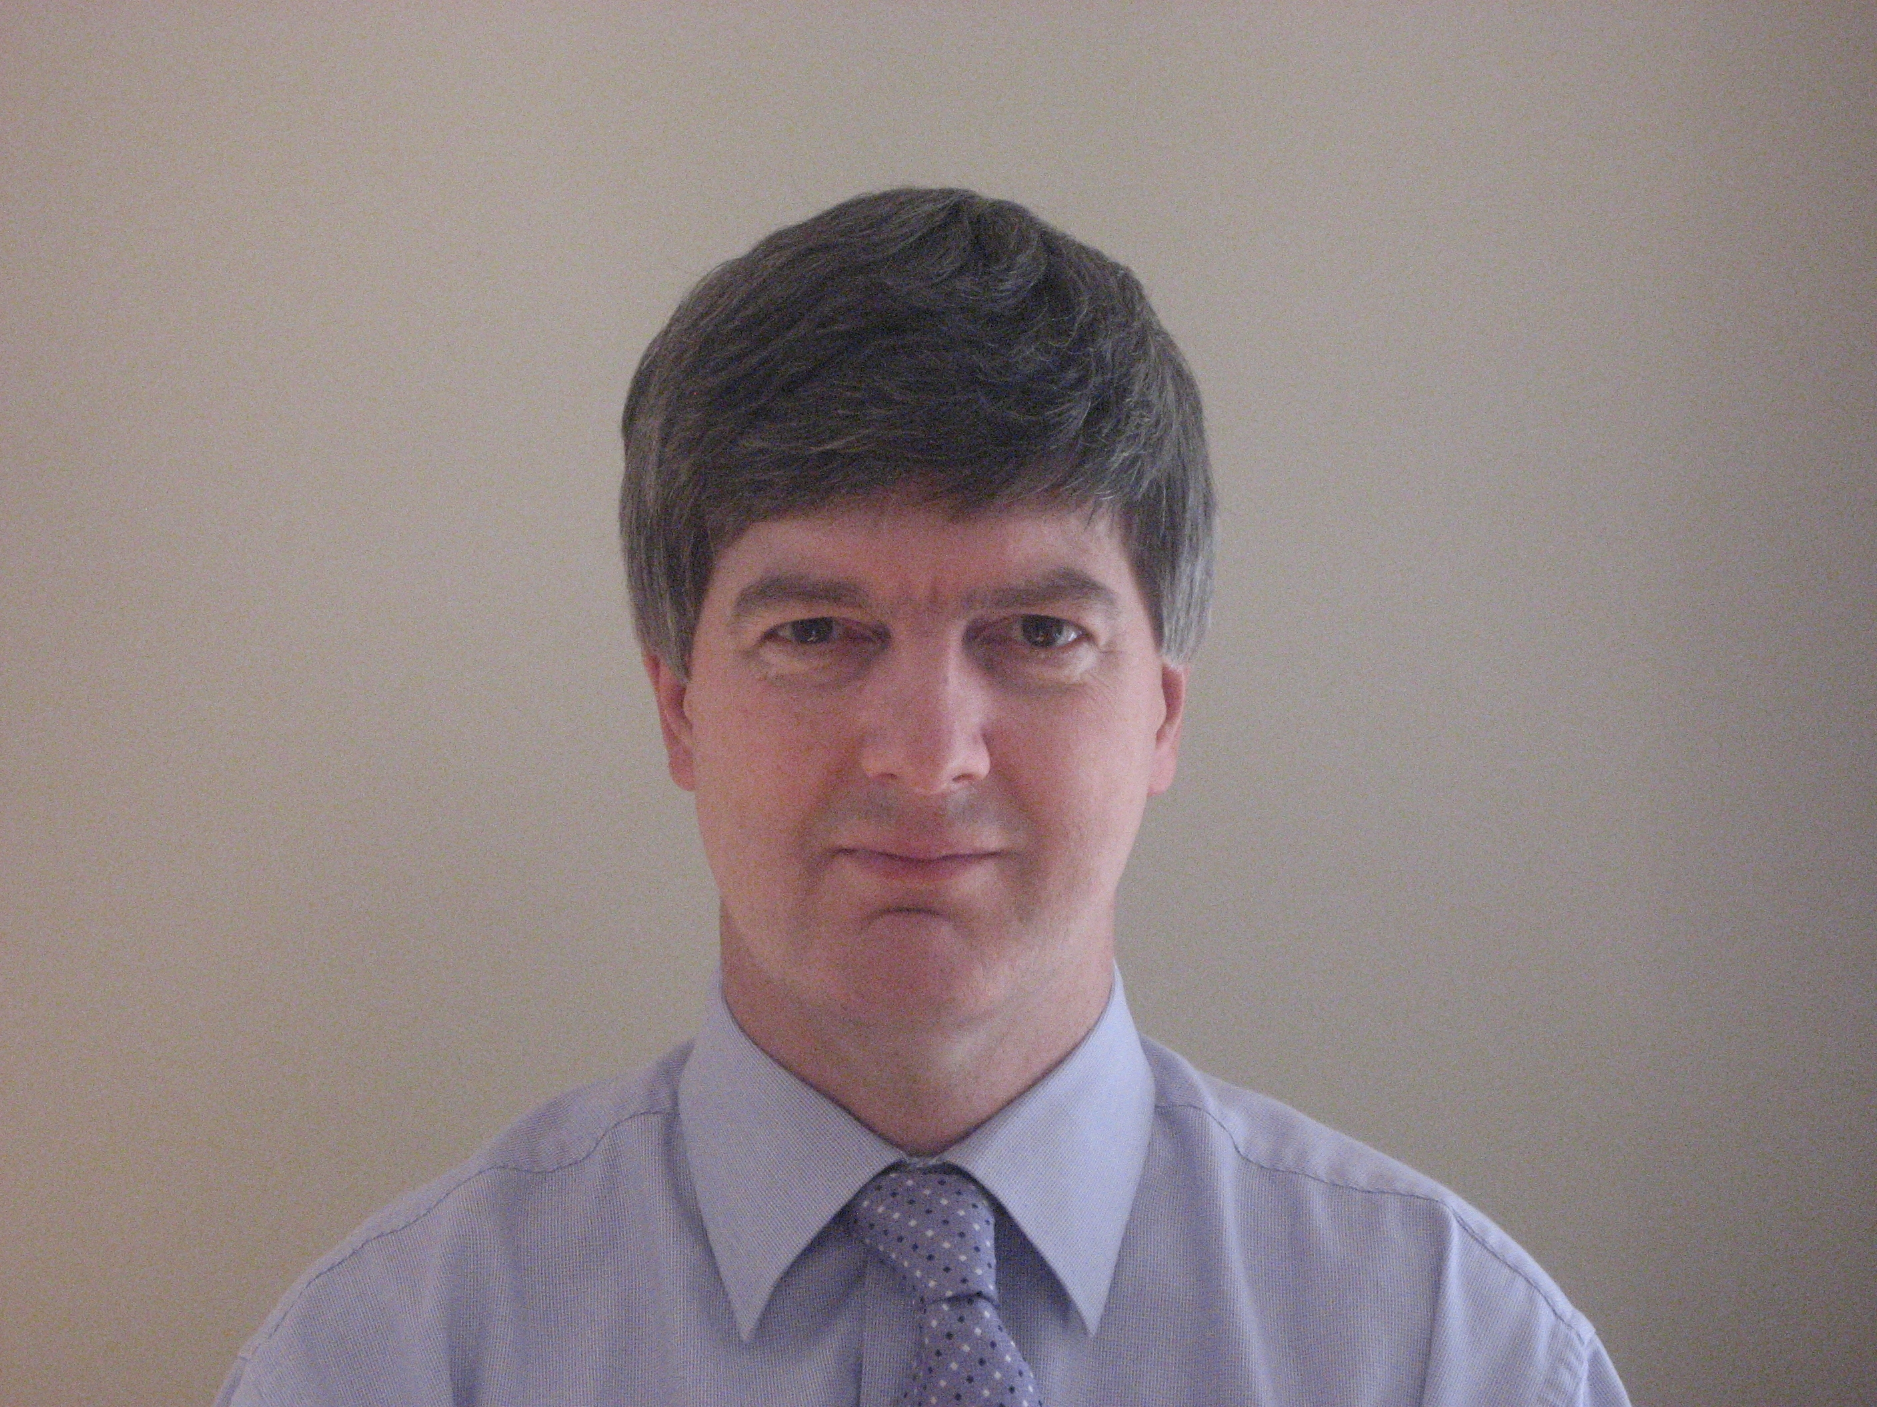

Alan is a consultant in environmental policy and business strategy. His recent work has included: developing ‘Innovation Programmes’ for the Agri-Food Sector in Northern Ireland; helping the GB Meat Industry bodies and the Sustainable Farming and Food Research Priorities Group (Defra), to define future research needs; working with the Countryside Council for Wales to enhance their external relations work and develop a strategy for National Nature Reserves; and supporting companies and cross-sector networks on roadmapping and risk management.

In 2004 he was appointed by Defra to Chair the Environment Agency Anglian Region Environment Protection Advisory Committee. This brings together diverse stakeholders to advise the Agency on its environmental protection and water management work. He is also a peer-reviewer for Defra.

Alan Chairs the National Conservation and Recreation Technical Panel of the Chartered Institution of Water and Environmental Management (CIWEM). He is also a Research Associate of the Countryside and Community Research Unit of the University of Gloucestershire.

Previously, he worked for the Country Land and Business Association (CLA) as Director of Strategy, and Deputy Director of Policy, leading on UK and EU policy on: water (resources, quality, navigation, flood risk management, fisheries); conservation (biodiversity, landscape, heritage); agri-environment policy (cross-compliance, Environmental Stewardship); and public access (open country, rights of way). He started his career with the RSPB, working on CAP reform, following PhD research into integrated land-use monitoring in the uplands of mid-Wales. His first degree, from Wye College, University of London, is in Rural Environment Studies.

